chapter 1
INTRODUCTION
The Collage Fees Management System is designed to automate the fee collection and record-keeping process in collages. Traditionally, fees are handled manually using registers, handwritten receipts, and basic spreadsheets, which often leads to errors, delays, and difficulty in maintaining accurate financial records. As collages grow, handling fee payments, generating receipts, and tracking dues becomes more challenging with manual methods.
A computerized system simplifies this process by offering a centralized platform where administrators can record payments, generate receipts, track outstanding balances, and maintain student fee histories. The main goal of this project is to provide a fast, secure, and user-friendly solution for managing collage fees efficiently. This system helps reduce manual work, improves accuracy, and ensures transparency in financial management.
1.1 Background of the Project
Many collages face difficulties in maintaining proper fee records due to the heavy dependence on manual processes. Physical ledgers may get damaged or misplaced, and verifying past fee transactions can take a lot of time. Parents may also face confusion when records are inconsistent or receipts are lost. In modern educational institutions, timely fee collection and proper financial documentation are essential for smooth functioning. The Collage Fees Management System provides a digital solution by storing all student and payment data in a secure database, making it easily accessible at any time. It reduces the workload of collage staff, minimizes the chances of calculation errors, and ensures that every payment is properly recorded. This background highlights the growing need for an automated and reliable fee management solution.
1.2 Problem Definition
Managing collage fees manually leads to errors, delays, and improper record keeping.
There is no quick method to track pending fees or generate accurate reports.
A digital system is needed to simplify fee management and ensure accuracy.
1.3 Objectives of the Project
- Automate the fee collection process
- Maintain proper student-wise fee records
- Generate receipts instantly
- Reduce calculation mistakes
- Provide quick reports of dues and payments

chapter 2
SCOPE OF THE PROJECT
The Collage Fees Management System is designed to be a complete and efficient solution for handling all fee-related tasks within an educational institution. The scope of this project covers all major operations involved in the fee collection process, such as managing student records, setting up fee structures, collecting payments, generating receipts, and tracking pending balances. This system ensures that data is stored securely and can be accessed easily whenever required. It also helps improve coordination between administrative staff, accounts departments, and parents by keeping fee records accurate and up to date.
The system is suitable for collages of all sizes, whether small institutions with a few hundred students or large collages with thousands of fee transactions every month. It allows administrators to define multiple fee categories including tuition fees, admission fees, library fees, examination fees, bus fees, sports fees, and other special charges. The project also supports the calculation of late fees or penalties in case of delayed payments. By providing real-time updates and automated calculations, the system ensures that all financial operations are carried out smoothly.
2.1 Inclusions Of The System
The system includes the following important features and functionalities:
- Student Registration Module: Allows storing and managing detailed student information.
- Fee Structure Management: Different classes and categories can have different fee structures.
- Fee Payment Management: Enables staff to record fee payments quickly and accurately.
- Receipt Generation: Automatically generates and prints/dowloads receipts after payment.
- Due Fee Tracking: Shows pending fees and defaulters’ list instantly.
- Reports Generation: Provides daily, monthly, and yearly reports for analysis.
- User Login Management: Ensures secure access with different roles.
- Database Storage: Stores all data safely in a digital database for future use.
2.2 Exclusions
The following features are not included in the basic version but can be added later:
- Online payment gateway integration (UPI, Net banking, Cards)
- Automatic SMS or email alerts for fee reminders
- Mobile application for parents
- Barcode or QR-based fee receipt system
2.3 Scope Summary
- The system improves fee collection and record keeping.
- It reduces paperwork and eliminates calculation mistakes.
- It provides real-time information about dues and payments.
- It ensures secure and organized financial management in collages.

chapter 3
SYSTEM DESIGN
System design plays a crucial role in developing a structured and efficient Collage Fees Management System. It involves planning how various components of the system will work together to achieve the required functionality. A well-designed system helps ensure smooth workflow, proper data management, and ease of use for all users. This chapter explains the architecture, diagrams, input and output designs, and database structure required to implement the system effectively.
The main purpose of system design is to convert user requirements into a technical blueprint. It provides a clear visualization of how the system will function internally, how data will flow between different modules, and how users will interact with the system. Designing also helps developers organize the database, define user interfaces, and plan the overall structure of the software. For a fee management system, accuracy, data security, and usability are essential aspects considered in the design phase.
The Collage Fees Management System follows a modular structure where each module handles a specific task such as student management, fee structure, payment entry, report generation, and user login. The integration among these modules allows the system to maintain consistent data and perform operations smoothly. The system design ensures that data flows seamlessly and that information is available in real-time to authenticated users.
3.1 System Architecture
The system is based on a three-tier architecture that divides the software into separate layers:
- Presentation Layer (Frontend):
This layer interacts with the user through web pages. It includes login screens, student forms, fee entry pages, receipt pages, and reports.
- Business Logic Layer (Backend):
This layer processes user inputs, executes calculations, validates fee data, updates transactions, and manages system logic.
- Database Layer:
This layer stores all information such as student details, fee categories, payment history, receipts, and report data.
This structured approach ensures efficient processing, easy maintenance, and better security.
3.2 Data Flow Diagram (DFD)
Level 1 DFD:
Includes four major processes:
- Student Registration
- Fee Structure Management
- Fee Payment Processing
- Report Generation
Each process exchanges data with the database to perform operations.
3.3 UML Diagrams
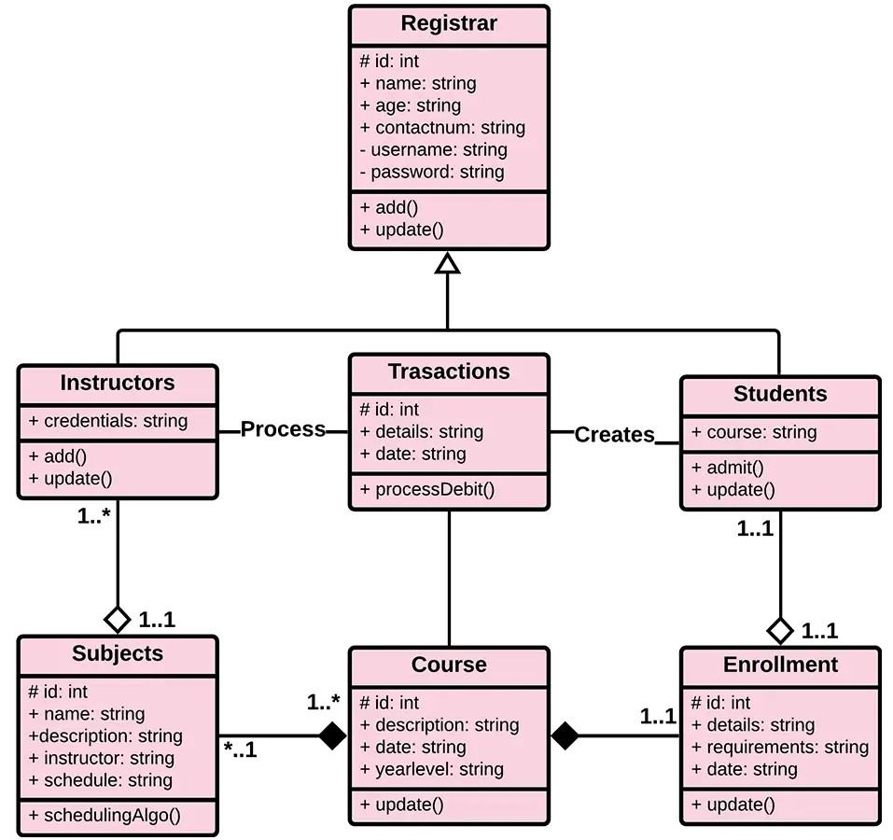
Class Diagram:

Fig 1.1 Class diagram of Collage fees management System
Each class contains attributes and functions related to fee operations.
Activity Diagram:
Shows the workflow of a fee payment process:
Login → Select Student → Enter Amount → Save Payment → Generate Receipt.
3.4 Database Design
The database contains multiple tables that store all relevant data securely.
Main Tables:
- Students: Stores student personal and academic details
- Fee Structure: Contains class-wise and category-wise fees
- Payments: Stores each payment entry made by staff
- Users: Stores login details for admin and staff
- Receipts: Stores receipt numbers and transaction details
The relational database ensures data consistency and fast retrieval.
3.5 Input Design
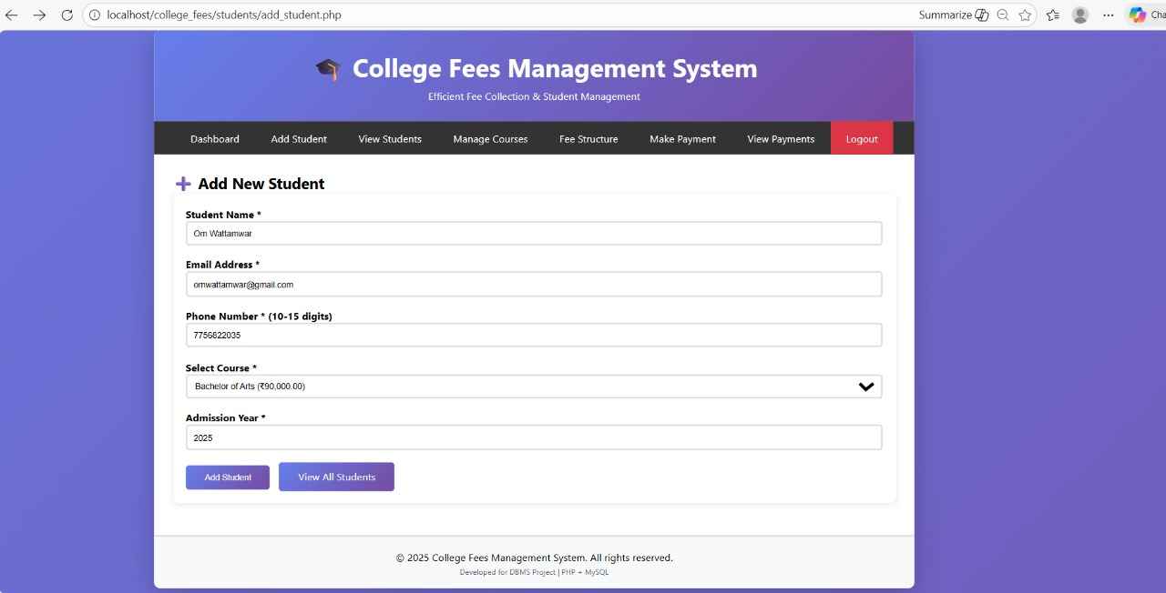
Fig 1.2 Add student to System

3.6 Output Design :
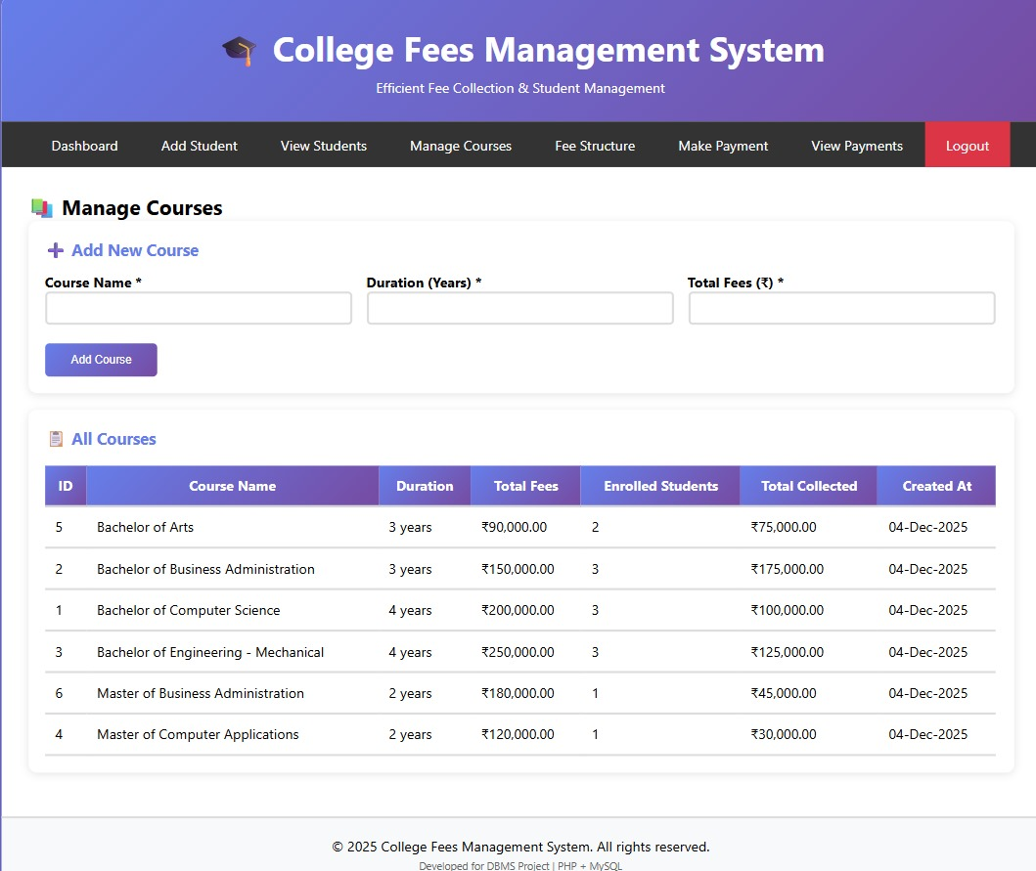

Fig 1.3 Dashboard of Collage fees Management System

chapter 4
SYSTEM IMPLEMENTATION
System implementation is the stage where the designed system is transformed into a working software application. It involves coding, integrating modules, configuring the database, and preparing the environment for execution. For the Collage Fees Management System, implementation ensures that all features such as fee entry, student registration, report generation, and receipt creation work smoothly as planned in earlier stages.
This phase also includes testing individual modules, checking compatibility with the required hardware and software, and ensuring that the system is ready for use by the collage staff. The implementation process is crucial because it determines the reliability and functioning of the final software. Proper installation, configuration, and user training are also part of the implementation process so that the users can operate the system without difficulties.
The implementation follows a structured approach: first developing core modules, then integrating them, and finally ensuring that all modules communicate properly with each other. Once coding is completed, the database is linked to the backend, and system interfaces are connected to the main application logic. After successful integration, the system is deployed in the collage environment where real-time data entry begins.
4.1 Technology Used
The project uses commonly available development tools and technologies to make implementation easy and reliable.
- Frontend: HTML, CSS, JavaScript
- Backend: PHP / Node.js (depending on project requirement)
- Database: MySQL
- Server Environment: XAMPP / WAMP / Apache
- Browser: Chrome, Firefox
These technologies ensure smooth functioning, fast performance, and secure data handling.

4.2 Module Description
The entire system is divided into several modules to simplify development and maintenance.
1. Login Module
- Provides secure access to admin and staff.
- Verifies username and password before allowing entry.
2. Student Management Module
- Stores and updates student profiles.
- Includes class, section, contact, and admission details.
3. Fee Structure Module
- Allows admin to set and modify fee categories.
- Supports tuition, library, bus, exam, and other fees.
4. Fee Payment Module
- Handles payment entry for students.
- Calculates pending amount automatically.
- Immediately generates digital receipt.
5. Due Fee Management Module
- Displays list of defaulters.
- Helps staff remind parents about pending dues.
6. Reports Module
- Generates daily collection reports, monthly summaries, and student histories.
- Supports printing and exporting data.
4.3 Database Implementation
Database implementation includes creating tables, defining relationships, and inserting initial data.

Fig 1.4 Database Of The Project

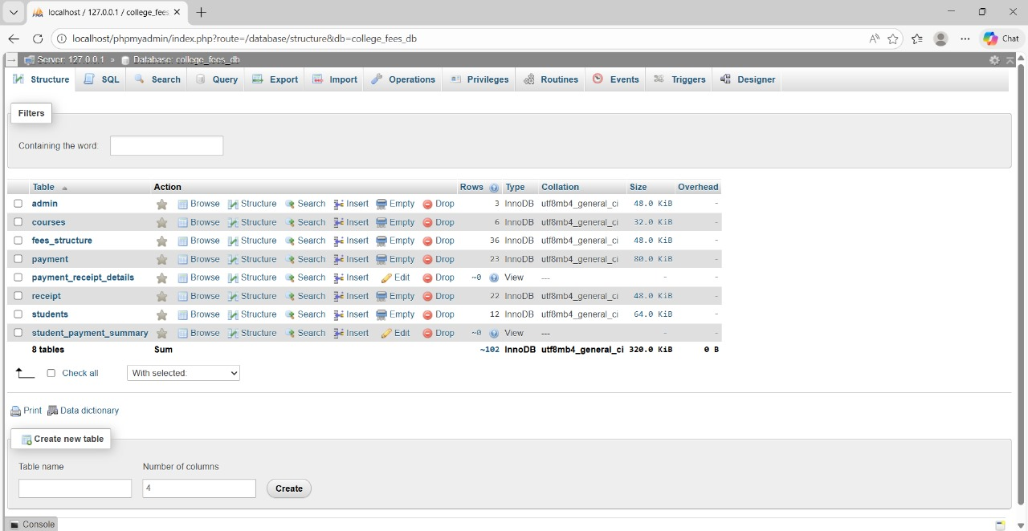
4.4 Integration of Modules
Each module is implemented and tested separately, then integrated with the main system.
Integration ensures:
- Smooth data flow
- Error-free calculations
- Correct communication between forms and database
- Accurate generation of receipts and reports
After integration, final testing is performed to ensure system stability.

chapter 5
TESTING & IMPLEMENTATION
The Testing and Implementation phase ensures that the Collage Fees Management System works correctly, meets user expectations, and performs efficiently in real-world conditions. Testing helps identify errors, bugs, or missing functionalities before the system is deployed for actual use. Implementation involves installing the system, configuring it for the collage environment, and making it accessible for administrators, staff, and users.
A thoroughly tested system improves reliability and user confidence. This chapter explains the testing methods used, the results obtained, and how the system was deployed successfully.
5.1 Testing Strategy
To ensure that the Collage Fees Management System functions correctly, multiple testing techniques were applied. The system was first tested module-wise to check basic functionality, such as login, student registration, payment processing, and report generation. Unit testing was performed to examine each individual component, ensuring that every function worked independently without errors. After that, integration testing verified the proper interaction between different modules. During system testing, the entire software was tested as a whole to confirm that it met the required features and performed smoothly under normal and abnormal conditions.
Additionally, user acceptance testing (UAT) was conducted by allowing staff or sample users to operate the system and provide feedback. Their suggestions were incorporated to improve ease of use, layout, and clarity of messages. This structured testing approach ensured a stable and reliable system ready for deployment.
5.2 Types of Testing Performed
1. Unit Testing
- Each module was tested separately
- Ensured no bugs in individual features
- Verified input validation and error messages
2. Integration Testing
- Checked communication between modules (e.g., fee payment → receipt generation)
- Ensured smooth data flow
- Verified database updates after actions
3. System Testing
- Complete system tested as a single unit
- Checked overall performance, security, and speed
- Verified functional and non-functional requirements
4. User Acceptance Testing (UAT)
- Conducted with selected collage staff
- Ensured system is user-friendly
- Feedback used to improve interface and usability
5.3 Test Case Examples
Test Case | Input | Expected Output | Result
Login | Correct username & password | Redirect to dashboard | Passed
Add Student | New student details | Student saved successfully | Passed
Fee Payment | Valid payment amount | Receipt generated | Passed
Report Generation | Month selection | Display report | Passed

5.4 Implementation
After the testing phase was successfully completed, the system was implemented in the collage environment. The installation included setting up the database, configuring user accounts, and making sure the system could run smoothly on available hardware. Training sessions were conducted for collage staff to help them understand how to use the system, enter data, and retrieve reports. User manuals were provided to guide them through common operations like recording payments and generating receipts.
During implementation, initial data such as student records, fee structures, and class details were added to the system. The administrator role was assigned to manage settings and user permissions. The system was then launched in real-time, allowing staff to start using it for daily fee transactions. Continuous support was provided during the initial weeks to ensure any minor issues could be solved instantly. After successful implementation, the collage was able to manage fees more efficiently and accurately.

CONCLUSION
The Collage Fees Management System successfully addresses the common challenges faced in traditional fee management processes within collages. Manual methods often lead to miscalculations, misplaced records, delays, and lack of transparency. By introducing automation, the system ensures that fee transactions are recorded accurately, receipts are generated instantly, and financial reports can be accessed at any time.
This project demonstrates how digital solutions can greatly improve administrative efficiency. With the use of a secure database, all student and payment information is stored systematically, reducing the chances of errors and data loss. The system also enhances communication between collage staff and parents by providing clear and consistent fee records.
Through proper testing and implementation, the system has proved to be reliable, efficient, and user-friendly. It not only simplifies the daily workload of collage administrators but also contributes to better financial management and smoother institutional operations. Overall, the Collage Fees Management System represents an important step toward modernization and improved accuracy in collage administration.

REFERENCE

1. Database System Concepts
Authors: Abraham Silberschatz, Henry F. Korth, S. Sudarshan
Publisher: McGraw-Hill
2. Fundamentals of Database Management Systems
Authors: Ramez Elmasri, Shamkant Navathe
Publisher: Pearson

3. Software Engineering: A Practitioner’s Approach
Author: Roger S. Pressman
Publisher: McGraw-Hill
4. Modern Operating Systems & Information Systems
Author: Kenneth C. Laudon & Jane P. Laudon
Publisher: Pearson

